

Faculty of Technology and Engineering
U & P U Patel Department of Computer Engineering
Date :/02/ 2023

Academic Year | : | 2022-23 | Semester | : | 4
Course code | : | CE246 | Course name | : | Database Management System

 | Practical-7
Aim: | To solve queries using the concept of sub query.
Theory:
Q-1 | Write a query to display the last name and hire date of any employee in the same department as smith. Exclude smith
Ans. | Select l_name,hiredate from employee  2 where dept_no=(select dept_no from employee where l_name ='Shah')  3 and l_name <>'Shah';  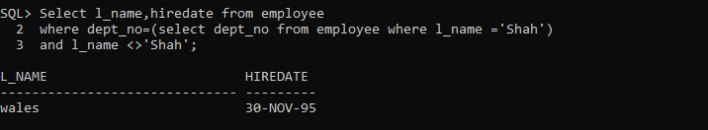
Q-2 | Give name of customers who are depositors having same branch city of mr. sunil.
Ans. | SELECT CNAME FROM CUSTOMER  2 WHERE CITY=(SELECT BNAME FROM DEPOSIT WHERE CNAME='sunil')  3 AND CUSTOMER.CNAME IN (SELECT CNAME FROM DEPOSIT);  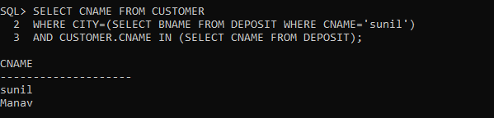
Q-3 | Give deposit details and loan details of customer in same city where pramod is living.
Ans. | SELECT distinct D1.A_NO,D1.BNAME , D1.AMOUNT , D1.A_DATE , B1.LOANNO , B1.BNAME , B1.AMOUNT FROM Deposit D1 ,  2 Borrow B1 , Customer C1 WHERE C1.CNAME = D1.CNAME  3 AND D1.CNAME=B1.CNAME AND C1.CITY IN (SELECT C2.CITY FROM Customer C2 WHERE C2.CNAME='Pramod');  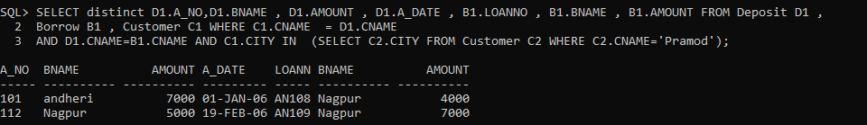
Q-4 | Create a query to display the employee numbers and last names of all employees who earn more than the average salary. Sort the results in ascending order of salary.
Ans. | Select emp_no, emp_name from Employee where emp_sal > (select Avg(emp_sal) from Employee) ORDER BY emp_sal;  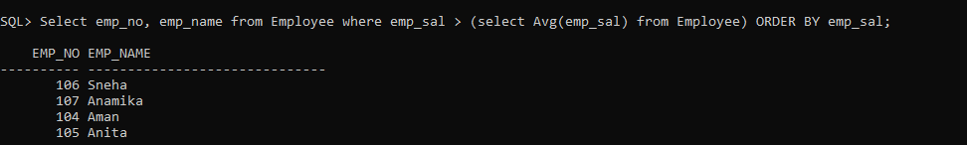
Q-5 | Give names of depositors having same living city as mr. anil and having deposit amount greater than 2000.
Ans. | SELECT CNAME FROM deposit  2 WHERE bname=(SELECT city FROM customer WHERE CNAME='anil')  3 AND Amount>2000;  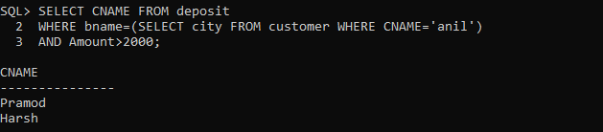
Q-6 | Display the last name and salary of every employee who reports to ford
Ans.
Q-7 | Display the department number, name, and job for every employee in the accounting department.
Ans. | SELECT e.DEPT_NO, e.DEPT_NAME, J.JOB_TITAL FROM Employee e, JOB J WHERE e.JOB_ID=J.JOB_ID AND J.JOB_TITAL='Account';
Q-8 | List the name of branch having highest number of depositors.
Ans. | SELECT BNAME FROM DEPOSIT HAVING COUNT(BNAME)=(SELECT MAX(COUNT(BNAME))  2 FROM DEPOSIT GROUP BY BNAME) GROUP BY BNAME;  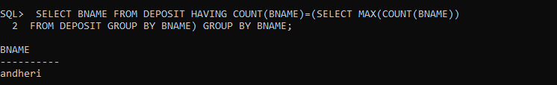
Q-9 | Give the name of cities where in which the maximum numbers of branches are located.
Ans. | SELECT CITY FROM customer HAVING COUNT(CITY)=(SELECT MAX(COUNT(bname))  2 FROM DEPOSIT GROUP BY bname) GROUP BY city;  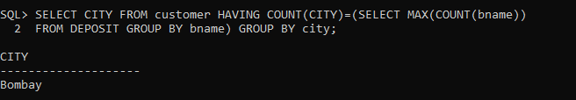
Q-10 | Give name of customers living in same city where maximum depositors are located.
Ans.

 | Practical-8(PART-1)
Aim: | Manipulating Data
Theory: | - The changing data to make it more organized and simpler to understand is referred to as data manipulation.  - Data manipulation is used to manipulate data in a database by inserting, removing, and changing data in order to cleanse or map the data.
Q-1 | Give 10% interest to all depositors.
Ans. | SELECT A_NO,CNAME,BNAME, (AMOUNT *0.10+AMOUNT) "NEW AMOUNT" FROM DEPOSIT;  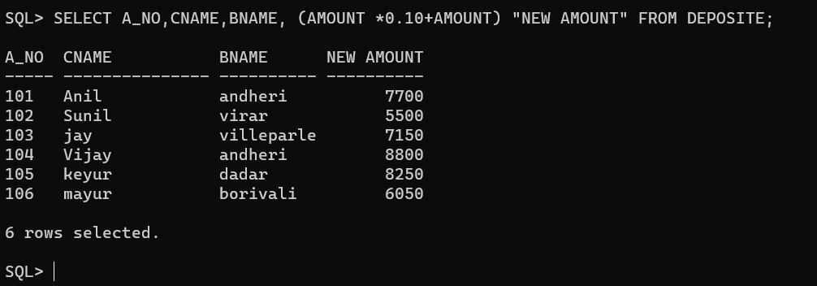
Q-2 | Give 10% interest to all depositors having branch vrce
Ans. | select a_no,cname,bname, (amount * 0.10 +amount) "new amount" ,a_date from deposit where bname='vrce';  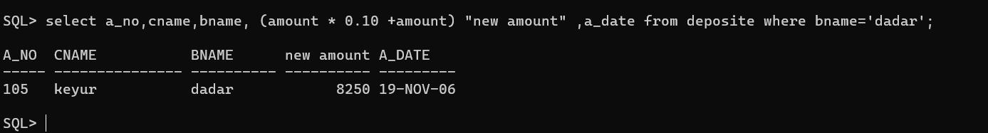
Q-3 | Give 10% interest to all depositors living in nagpur and having branch city bombay.
Ans. | SELECT D.A_NO , D.CNAME , D.BNAME , (D.AMOUNT * 0.10 + D.AMOUNT) "NEW AMOUNT" FROM DEPOSIT D  INNER JOIN CUSTOMER C ON C.CNAME = D.CNAME  where D.bname = 'Nagpur' AND C.CITY = 'Bombay';  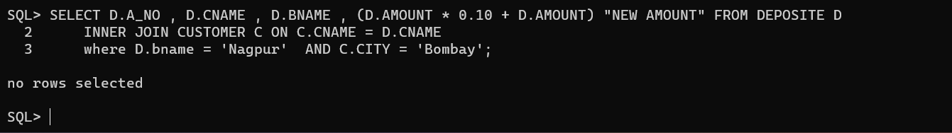
Q-4 | Write a query which changes the department number of all employees with empno 7788’s job to employee 7844’current department number
Ans. | UPDATE EMPLOYEE SET dept_NO = 35 WHERE dept_NO = 20;  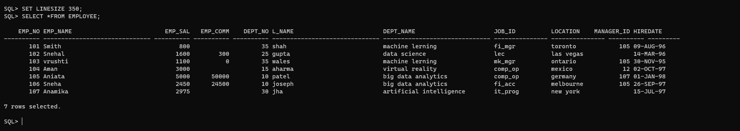
Q-5 | Transfer 10 Rs from account of anil to sunil if both are having same branch.
Ans.
Q-6 | Give 100 Rs more to all depositors if they are maximum depositors in their respective branch.
Ans. | SELECT CNAME , (AMOUNT+100) FROM DEPOSIT WHERE AMOUNT =(SELECT MAX(AMOUNT) FROM DEPOSIT );  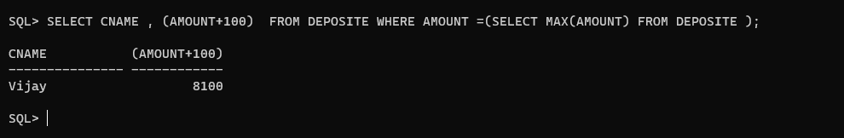
Q-7 | Delete depositors of branches having number of customers between 1 to 3.
Ans.
Q-8 | Delete deposit of vijay.
Ans. | 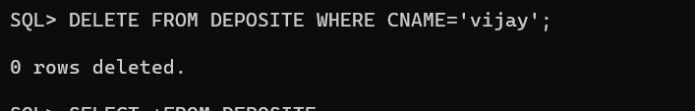
Q-9 | Delete borrower of branches having average loan less than 1000.
Ans. | DELETE FROM BORROW WHERE AMOUNT < 1000;  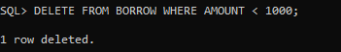

 | Practical-9
Aim: | Add and Remove constraint
1 | Add primary key constraint on job_id in job table.
Ans, | alter table job add constraint adding_to_job_id primary key(job_id);  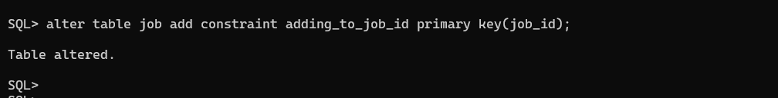
2 | Add foreign key constraint on employee table referencing job table.
Ans. | LTER TABLE EMPLOYEE ADD CONSTRAINT ADDING_FK FOREIGN KEY  2 (JOB_ID) REFERENCES JOB(JOB_ID);  
3 | Add composite primary key on lock table (lock table does not exist, while creating table add composite key).
Ans.
4 | Remove primary key constraint on job_id
Ans. | ALTER TABLE EMPLOYEE DROP CONSTRAINT ADDING_FK;  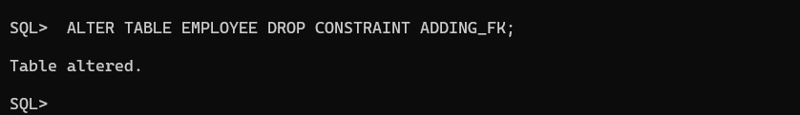
5 | Remove foreign key constraint on employee table
Ans | ALTER TABLE JOB DROP PRIMARY KEY;  

_________
_________________

Faculty signature Grade

